DSA LAB 3 POST LAB TASKS
NAME: MUHAMMAD ANAS | ID: 25K-0577 | SECTION: BCS-3A

TASK 3:
CODE:
#include <iostream>
using namespace std;

void insertionSort(int arr[], int n){
for(int i=1; i<n; i++){
int key = arr[i];
int j = i-1;

while(j>=0 && arr[j]>key){
arr[j+1] = arr[j];
j--;
}

arr[j+1] = key;

cout << "After insertion " << i << ": ";
for(int k=0; k<n; k++){
cout << arr[k] << " ";
}
cout << endl;
}
}

int main(){
int n;
cout << "Enter number of days: ";
cin >> n;

int arr[n];

for(int i=0; i<n; i++){
cout << "Enter Day " << i+1 << " Temperature: ";
cin >> arr[i];
}

cout << "\nArray Before Sorting: ";
for(int i=0; i<n; i++){
cout << arr[i] << " ";
}

cout << "\n\nInsertion Sort Steps:\n";
insertionSort(arr, n);

cout << "\nArray After Sorting: ";
for(int i=0; i<n; i++){
cout << arr[i] << " ";
}

return 0;
}

OUTPUT:
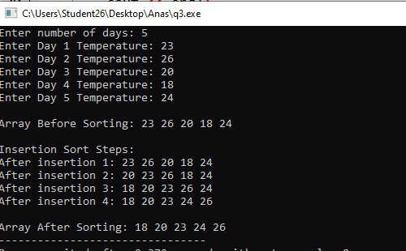

TASK 4:
CODE:
#include <iostream>
using namespace std;

void shellSort(int arr[], int n){
for(int gap=n/2; gap>0; gap/=2){

for(int i=gap; i<n; i++){
int key = arr[i];
int j = i- gap;

while(j>=0 && arr[j]>key){
arr[j+gap] = arr[j];
j = j-gap;
}

arr[j+gap] = key;
}

cout << "After gap " << gap << ": ";
for(int i=0; i<n; i++){
cout << arr[i] << " ";
}
cout << endl;
}
}

int main(){
int n;
cout << "Enter number of employees: ";
cin >> n;

int arr[n];

for(int i=0; i<n; i++){
cout << "Enter Employee " << i+1 << " Score: ";
cin >> arr[i];
}

cout << "\nArray Before Sorting: ";
for(int i=0; i<n; i++){
cout << arr[i] << " ";
}

cout << "\n\nShell Sort Passes:\n";
shellSort(arr, n);

cout << "\nArray After Sorting: ";
for(int i=0; i<n; i++){
cout << arr[i] << " ";
}

return 0;
}

OUTPUT:
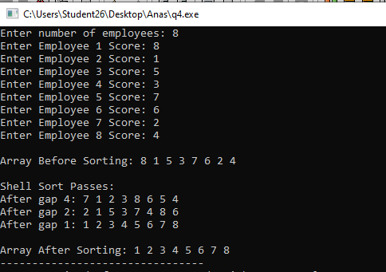

TASK 5:
CODE:
#include <iostream>
using namespace std;

void combSort(int arr[], int n){
int gap = n;
bool swapped = true;

while(gap > 1 || swapped){
gap /= 1.3;

if(gap < 1) gap = 1;

swapped = false;

for(int j=0; j+gap<n; j++){
if(arr[j] > arr[j+gap]){
int temp = arr[j];
arr[j] = arr[j+gap];
arr[j+gap] = temp;
swapped = true;
}
}

cout << "Gap: " << gap << endl;
}
}

int main(){
int n;
cout << "Enter number of products: ";
cin >> n;

int arr[n];

for(int i=0; i<n; i++){
cout << "Enter Product " << i+1 << " Code: ";
cin >> arr[i];
}

cout << "\nArray Before Sorting: ";
for(int i=0; i<n; i++){
cout << arr[i] << " ";
}

cout << "\n\nComb Sort Gaps:\n";
combSort(arr, n);

cout << "\nArray After Sorting: ";
for(int i=0; i<n; i++){
cout << arr[i] << " ";
}

return 0;
}

OUTPUT:
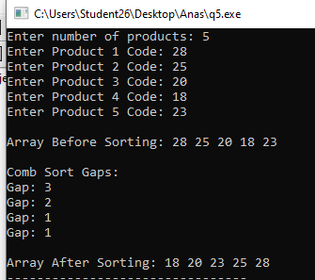

TASK 6:
CODE:
#include <iostream>
using namespace std;

void linearSearch(int arr[], int n, int key){
int count = 0;

for(int i=0; i<n; i++){
count++;

if(arr[i] == key){
cout << "Element found at index: " << i << endl;
cout << "Total Comparisons: " << count << endl;
return;
}
}

cout << "Element does not exist in this array" << endl;
cout << "Total Comparisons: " << count << endl;
}

int main(){

int n;

cout << "Enter number of students: ";
cin >> n;

int arr[n];

for(int i=0; i<n; i++){
cout << "Enter Roll Number " << i+1 << ": ";
cin >> arr[i];
}

int key;

cout << "Enter Roll Number to search: ";
cin >> key;

cout << "Sorting Necessary: No (because we are using linear search in which we compare one by one each element)" << endl;

linearSearch(arr, n, key);

return 0;
}

OUTPUT:
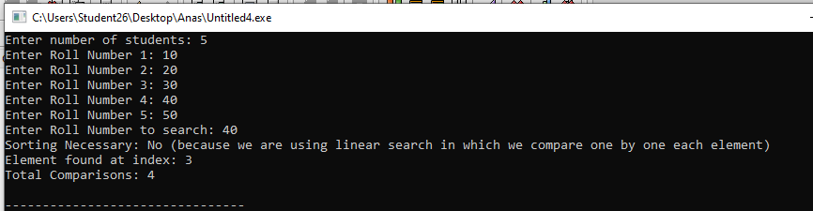

TASK 7:
CODE:
#include <iostream>
using namespace std;

void combSort(int arr[], int n){
int gap = n;
bool swapped = true;

while(gap > 1 || swapped){
gap /= 1.3;

if(gap < 1) gap = 1;

swapped = false;

for(int j=0; j+gap<n; j++){
if(arr[j] > arr[j+gap]){
int temp = arr[j];
arr[j] = arr[j+gap];
arr[j+gap] = temp;
swapped = true;
}
}
}
}

int binarySearch(int arr[], int n, int key){
int low = 0;
int high = n-1;

while(low <= high){
int mid = (low+high)/2;

cout << "low: " << low << ", high: " << high << ", mid: " << mid << endl;

if(arr[mid] == key) return mid;
else if(arr[mid] > key) high = mid-1;
else low = mid+1;
}

return -1;
}

int main(){
int n;
cout << "Enter number of products: ";
cin >> n;

int arr[n];

for(int i=0; i<n; i++){
cout << "Enter Product " << i+1 << " ID: ";
cin >> arr[i];
}

cout << "\nArray Before Sorting: ";
for(int i=0; i<n; i++){
cout << arr[i] << " ";
}

combSort(arr, n);

cout << "\nArray After Sorting: ";
for(int i=0; i<n; i++){
cout << arr[i] << " ";
}
cout << endl << endl;

int key;
cout << "Enter Product ID to search: ";
cin >> key;

cout << "\nBinary Search Pointer Values\n";
int result = binarySearch(arr, n, key);

if(result == -1){
cout << "Element Does Not Exist!!" << endl;
}
else{
cout << "Element found at index: " << result << endl;
}

return 0;
}

OUTPUT:
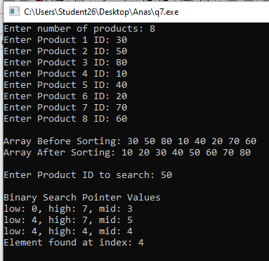

TASK 8:
CODE:
#include <iostream>
using namespace std;

int interpolationSearch(int arr[], int n, int key){
int low = 0;
int high = n-1;

while(low <= high && key <= arr[high] && key >= arr[low]){

if(arr[low] == arr[high]){
if(arr[low] == key){
cout << "estimated position: " << low << endl;
return low;
}
else{
return -1;
}
}

int pos = low + ((key - arr[low]) * (high - low)) / (arr[high] - arr[low]);

cout << "estimated position: " << pos << endl;

if(arr[pos] == key) return pos;
else if(arr[pos] > key) high = pos-1;
else low = pos+1;
}

return -1;
}

int main(){
int n;
cout << "Enter number of students: ";
cin >> n;

int arr[n];

for(int i=0; i<n; i++){
cout << "Enter Student " << i+1 << " Score: ";
cin >> arr[i];
}

cout << "\nArray: ";
for(int i=0; i<n; i++){
cout << arr[i] << " ";
}

int key;
cout << "\n\nEnter Student Score to search: ";
cin >> key;

cout << "\n\nInterpolation Search Estimations:\n";
int result = interpolationSearch(arr, n, key);

if(result == -1){
cout << "Element Does Not Exist!!" << endl;
}
else{
cout << "Element found at index: " << result << endl;
}

return 0;
}

OUTPUT:
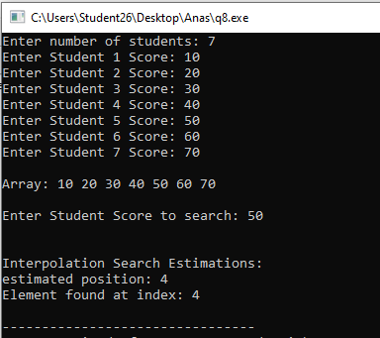
TASK 9:
CODE:
#include <iostream>
using namespace std;

struct Result{
int comparisons;
int swaps;
};

Result bubbleSort(int arr[], int n){
int comparisons = 0;
int swaps = 0;

for(int i=0; i<n-1; i++){
bool swapped = false;

for(int j=0; j<n-i-1; j++){
comparisons++;

if(arr[j] > arr[j+1]){
int temp = arr[j];
arr[j] = arr[j+1];
arr[j+1] = temp;

swapped = true;
swaps++;
}
}

if(!swapped) break;
}

return {comparisons, swaps};
}

Result selectionSort(int arr[], int n){
int comparisons = 0;
int swaps = 0;

for(int i=0; i<n-1; i++){
int minIdx = i;

for(int j=i+1; j<n; j++){
comparisons++;

if(arr[j] < arr[minIdx]){
minIdx = j;
}
}

if(minIdx != i){
int temp = arr[minIdx];
arr[minIdx] = arr[i];
arr[i] = temp;

swaps++;
}
}

return {comparisons, swaps};
}

Result insertionSort(int arr[], int n){
int comparisons = 0;
int swaps = 0;

for(int i=1; i<n; i++){
int key = arr[i];
int j = i-1;

while(j>=0){
comparisons++;

if(arr[j] > key){
arr[j+1] = arr[j];
swaps++;
j--;
}
else{
break;
}
}

arr[j+1] = key;
}

return {comparisons, swaps};
}

Result shellSort(int arr[], int n){
int comparisons = 0;
int swaps = 0;

for(int gap=n/2; gap>0; gap/=2){
for(int i=gap; i<n; i++){
int key = arr[i];
int j = i-gap;

while(j>=0){
comparisons++;

if(arr[j] > key){
arr[j+gap] = arr[j];
swaps++;
j = j-gap;
}
else{
break;
}
}

arr[j+gap] = key;
}
}

return {comparisons, swaps};
}

Result combSort(int arr[], int n){
int comparisons = 0;
int swaps = 0;

int gap = n;
bool swapped = true;

while(gap>1 || swapped){
gap /= 1.3;

if(gap<1) gap = 1;

swapped = false;

for(int j=0; j+gap<n; j++){
comparisons++;

if(arr[j] > arr[j+gap]){
int temp = arr[j];
arr[j] = arr[j+gap];
arr[j+gap] = temp;

swapped = true;
swaps++;
}
}
}

return {comparisons, swaps};
}

int linearSearch(int arr[], int n, int key, int &comparisons){
comparisons = 0;

for(int i=0; i<n; i++){
comparisons++;

if(arr[i] == key){
return i;
}
}

return -1;
}

int binarySearch(int arr[], int n, int key, int &comparisons){
int low = 0;
int high = n-1;

comparisons = 0;

while(low <= high){
int mid = (low+high)/2;

comparisons++;

if(arr[mid] == key){
return mid;
}
else if(arr[mid] > key){
high = mid-1;
}
else{
low = mid+1;
}
}

return -1;
}

int interpolationSearch(int arr[], int n, int key, int &comparisons){
int low = 0;
int high = n-1;

comparisons = 0;

while(low <= high && key >= arr[low] && key <= arr[high]){

if(arr[low] == arr[high]){
comparisons++;

if(arr[low] == key){
return low;
}
else{
return -1;
}
}

int pos = low + ((key-arr[low])*(high-low))
/(arr[high]-arr[low]);

comparisons++;

cout << "Estimated Position: " << pos << endl;

if(arr[pos] == key){
return pos;
}
else if(arr[pos] > key){
high = pos-1;
}
else{
low = pos+1;
}
}

return -1;
}

void copyArray(int original[], int copy[], int n){
for(int i=0; i<n; i++){
copy[i] = original[i];
}
}

void displayArray(int arr[], int n){
for(int i=0; i<n; i++){
cout << arr[i] << " ";
}
cout << endl;
}

int main(){

int n;

cout << "Enter number of elements: ";
cin >> n;

int original[n];

for(int i=0; i<n; i++){
cout << "Enter Element " << i+1 << ": ";
cin >> original[i];
}

cout << "\nOriginal Array: ";
displayArray(original, n);

int arr[n];
Result result;

copyArray(original, arr, n);
result = bubbleSort(arr, n);

cout << "\nBubble Sort:";
cout << "\nComparisons: " << result.comparisons;
cout << "\nSwaps: " << result.swaps;
cout << "\nSorted Array: ";
displayArray(arr, n);

copyArray(original, arr, n);
result = selectionSort(arr, n);

cout << "\nSelection Sort:";
cout << "\nComparisons: " << result.comparisons;
cout << "\nSwaps: " << result.swaps;
cout << "\nSorted Array: ";
displayArray(arr, n);

copyArray(original, arr, n);
result = insertionSort(arr, n);

cout << "\nInsertion Sort:";
cout << "\nComparisons: " << result.comparisons;
cout << "\nShifts: " << result.swaps;
cout << "\nSorted Array: ";
displayArray(arr, n);

copyArray(original, arr, n);
result = shellSort(arr, n);

cout << "\nShell Sort:";
cout << "\nComparisons: " << result.comparisons;
cout << "\nShifts: " << result.swaps;
cout << "\nSorted Array: ";
displayArray(arr, n);

copyArray(original, arr, n);
result = combSort(arr, n);

cout << "\nComb Sort:";
cout << "\nComparisons: " << result.comparisons;
cout << "\nSwaps: " << result.swaps;
cout << "\nSorted Array: ";
displayArray(arr, n);

copyArray(original, arr, n);
combSort(arr, n);

int key;

cout << "\nEnter value to search: ";
cin >> key;

cout << "\nSearching in Sorted Array:\n";
displayArray(arr, n);

int comparisons;

int linearResult = linearSearch(arr, n, key, comparisons);

cout << "\nLinear Search:";
if(linearResult == -1){
cout << "\nElement Does Not Exist";
}
else{
cout << "\nElement found at index: " << linearResult;
}
cout << "\nComparisons: " << comparisons << endl;

int binaryResult = binarySearch(arr, n, key, comparisons);

cout << "\nBinary Search:";
if(binaryResult == -1){
cout << "\nElement Does Not Exist";
}
else{
cout << "\nElement found at index: " << binaryResult;
}
cout << "\nComparisons: " << comparisons << endl;

cout << "\nInterpolation Search:";
int interpolationResult = interpolationSearch(arr, n, key, comparisons);

if(interpolationResult == -1){
cout << "Element Does Not Exist";
}
else{
cout << "Element found at index: " << interpolationResult;
}
cout << "\nComparisons: " << comparisons << endl;

cout << "\n\nComplexity Comparison:\n";

cout << "\nBubble Sort";
cout << "\nBest: O(n)";
cout << "\nAverage: O(n^2)";
cout << "\nWorst: O(n^2)";
cout << "\nSpace: O(1)\n";

cout << "\nSelection Sort";
cout << "\nBest: O(n^2)";
cout << "\nAverage: O(n^2)";
cout << "\nWorst: O(n^2)";
cout << "\nSpace: O(1)\n";

cout << "\nInsertion Sort";
cout << "\nBest: O(n)";
cout << "\nAverage: O(n^2)";
cout << "\nWorst: O(n^2)";
cout << "\nSpace: O(1)\n";

cout << "\nShell Sort";
cout << "\nBest: O(n log n)";
cout << "\nAverage: Depends on gap sequence";
cout << "\nWorst: O(n^2)";
cout << "\nSpace: O(1)\n";

cout << "\nComb Sort";
cout << "\nBest: O(n log n)";
cout << "\nAverage: O(n^2)";
cout << "\nWorst: O(n^2)";
cout << "\nSpace: O(1)\n";

cout << "\nLinear Search";
cout << "\nBest: O(1)";
cout << "\nAverage: O(n)";
cout << "\nWorst: O(n)";
cout << "\nSpace: O(1)\n";

cout << "\nBinary Search";
cout << "\nBest: O(1)";
cout << "\nAverage: O(log n)";
cout << "\nWorst: O(log n)";
cout << "\nSpace: O(1)\n";

cout << "\nInterpolation Search";
cout << "\nBest: O(1)";
cout << "\nAverage: O(log log n)";
cout << "\nWorst: O(n)";
cout << "\nSpace: O(1)\n";

cout << "\nAppropriate Technique Based on Data:\n";
cout << "Sorting: Comb Sort or Shell Sort can be considered for general unsorted data.\n";
cout << "Searching: Binary Search is suitable for sorted data.\n";
cout << "Interpolation Search is suitable when sorted values are approximately uniformly distributed.\n";

return 0;
}

OUTPUT:
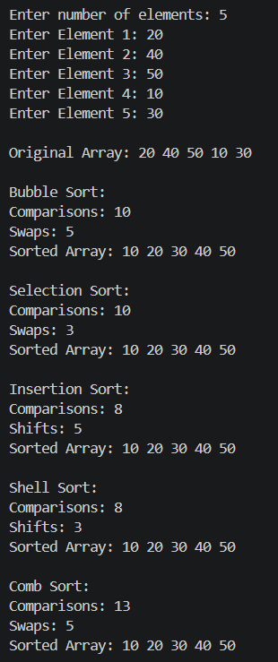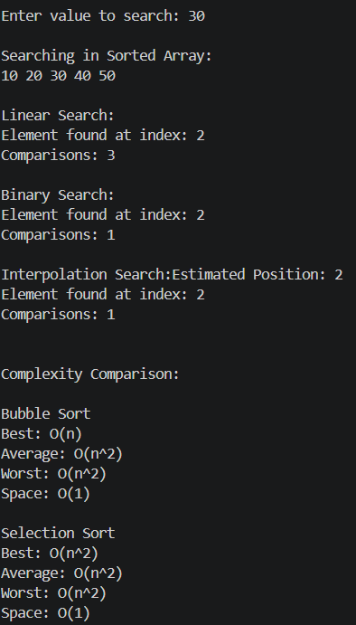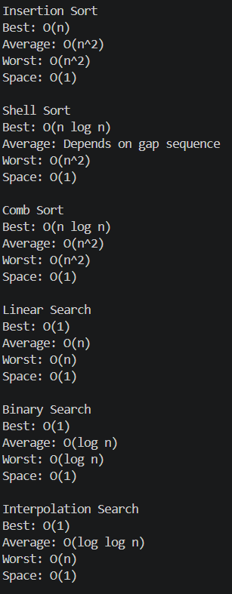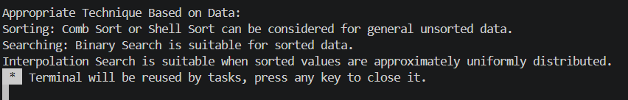

TASK 10:
CODE:
#include <iostream>
using namespace std;

void display(int arr[], int n){
for(int i=0; i<n; i++){
cout << arr[i] << " ";
}
cout << endl;
}

void copyArray(int original[], int arr[], int n){
for(int i=0; i<n; i++){
arr[i] = original[i];
}
}

void bubbleSort(int arr[], int n){
for(int i=0; i<n-1; i++){
bool swapped = false;

for(int j=0; j<n-i-1; j++){
if(arr[j] > arr[j+1]){
int temp = arr[j];
arr[j] = arr[j+1];
arr[j+1] = temp;
swapped = true;
}
}

if(!swapped)
break;
}
}

void selectionSort(int arr[], int n){
for(int i=0; i<n-1; i++){
int minIndex = i;

for(int j=i+1; j<n; j++){
if(arr[j] < arr[minIndex]){
minIndex = j;
}
}

int temp = arr[i];
arr[i] = arr[minIndex];
arr[minIndex] = temp;
}
}

void insertionSort(int arr[], int n){
for(int i=1; i<n; i++){
int key = arr[i];
int j = i-1;

while(j>=0 && arr[j]>key){
arr[j+1] = arr[j];
j--;
}

arr[j+1] = key;
}
}

void shellSort(int arr[], int n){
for(int gap=n/2; gap>0; gap/=2){

for(int i=gap; i<n; i++){
int key = arr[i];
int j = i-gap;

while(j>=0 && arr[j]>key){
arr[j+gap] = arr[j];
j = j-gap;
}

arr[j+gap] = key;
}
}
}

void combSort(int arr[], int n){
int gap = n;
bool swapped = true;

while(gap>1 || swapped){

gap = gap / 1.3;

if(gap<1)
gap = 1;

swapped = false;

for(int j=0; j+gap<n; j++){
if(arr[j] > arr[j+gap]){
int temp = arr[j];
arr[j] = arr[j+gap];
arr[j+gap] = temp;
swapped = true;
}
}
}
}

int linearSearch(int arr[], int n, int key){
for(int i=0; i<n; i++){
cout << "Checking index " << i << endl;

if(arr[i] == key)
return i;
}

return -1;
}

int binarySearch(int arr[], int n, int key){
int low = 0;
int high = n-1;

while(low<=high){

int mid = (low+high)/2;

cout << "Low: " << low
<< " High: " << high
<< " Mid: " << mid << endl;

if(arr[mid] == key)
return mid;

else if(arr[mid] > key)
high = mid-1;

else
low = mid+1;
}

return -1;
}

int interpolationSearch(int arr[], int n, int key){
int low = 0;
int high = n-1;

while(low<=high && key>=arr[low] && key<=arr[high]){

if(arr[low] == arr[high]){
if(arr[low] == key)
return low;
else
return -1;
}

int pos = low + ((key-arr[low])*(high-low))
/ (arr[high]-arr[low]);

cout << "Estimated Position: " << pos << endl;

if(arr[pos] == key)
return pos;

else if(arr[pos] > key)
high = pos-1;

else
low = pos+1;
}

return -1;
}

int main(){

int n;

cout << "Enter number of student marks: ";
cin >> n;

int original[n];
int arr[n];

cout << "Enter student marks:\n";

for(int i=0; i<n; i++){
cin >> original[i];
}

cout << "\nOriginal Data: ";
display(original, n);

int choice;

do{
cout << "\n========== MENU ==========\n";
cout << "1. Bubble Sort\n";
cout << "2. Selection Sort\n";
cout << "3. Insertion Sort\n";
cout << "4. Shell Sort\n";
cout << "5. Comb Sort\n";
cout << "6. Linear Search\n";
cout << "7. Binary Search\n";
cout << "8. Interpolation Search\n";
cout << "9. Complexity Comparison\n";
cout << "0. Exit\n";
cout << "Enter your choice: ";
cin >> choice;

if(choice>=1 && choice<=5){

copyArray(original, arr, n);

if(choice==1){
bubbleSort(arr, n);
cout << "\nBubble Sort Result: ";
}

else if(choice==2){
selectionSort(arr, n);
cout << "\nSelection Sort Result: ";
}

else if(choice==3){
insertionSort(arr, n);
cout << "\nInsertion Sort Result: ";
}

else if(choice==4){
shellSort(arr, n);
cout << "\nShell Sort Result: ";
}

else if(choice==5){
combSort(arr, n);
cout << "\nComb Sort Result: ";
}

display(arr, n);
}

else if(choice>=6 && choice<=8){

int key;
cout << "\nEnter mark to search: ";
cin >> key;

copyArray(original, arr, n);

if(choice==6){

cout << "\nLinear Search:\n";

int result = linearSearch(arr, n, key);

cout << "Index: " << result << endl;

cout << "Sorting Required: No\n";
cout << "Reason: Linear Search can work on unsorted data.\n";
}

else{

cout << "\nSorting is required before this search.\n";

bubbleSort(arr, n);

cout << "Sorted Data: ";
display(arr, n);

if(choice==7){

cout << "\nBinary Search Steps:\n";

int result = binarySearch(arr, n, key);

cout << "Index: " << result << endl;

cout << "Sorting Required: Yes\n";
cout << "Reason: Binary Search requires sorted data.\n";
}

else{

cout << "\nInterpolation Search Steps:\n";

int result = interpolationSearch(arr, n, key);

cout << "Index: " << result << endl;

cout << "Sorting Required: Yes\n";
cout << "Reason: Interpolation Search requires sorted data.\n";
cout << "It is most suitable for approximately uniform data.\n";
}
}
}

else if(choice==9){

cout << "\n====== COMPLEXITY COMPARISON ======\n";

cout << "\nSorting Algorithms:\n";

cout << "Bubble Sort : Best O(n), Average O(n^2), Worst O(n^2), Space O(1)\n";
cout << "Selection Sort : Best O(n^2), Average O(n^2), Worst O(n^2), Space O(1)\n";
cout << "Insertion Sort : Best O(n), Average O(n^2), Worst O(n^2), Space O(1)\n";
cout << "Shell Sort : Depends on gap sequence, Worst commonly O(n^2), Space O(1)\n";
cout << "Comb Sort : Best O(n log n), Average O(n^2), Worst O(n^2), Space O(1)\n";

cout << "\nSearching Algorithms:\n";

cout << "Linear Search : Best O(1), Average O(n), Worst O(n), Space O(1)\n";
cout << "Binary Search : Best O(1), Average O(log n), Worst O(log n), Space O(1)\n";
cout << "Interpolation Search: Best O(1), Average O(log log n), Worst O(n), Space O(1)\n";

cout << "\n====== APPROPRIATE TECHNIQUE ======\n";

cout << "Unsorted data: Linear Search can be used directly.\n";
cout << "Nearly sorted data: Insertion Sort is suitable.\n";
cout << "General unsorted data: Shell Sort or Comb Sort can be used.\n";
cout << "Sorted data: Binary Search is suitable.\n";
cout << "Approximately uniform sorted data: Interpolation Search can be suitable.\n";
}

else if(choice==0){
cout << "\nProgram ended.\n";
}

else{
cout << "\nInvalid choice!\n";
}

}while(choice!=0);

return 0;
}

OUTPUT:
